INSTRUCTIONS (Please PRINT all information clearly)
- Complete Section 1, 2, and 3.
- Read the Visiting Child Induction information attached to this form.
- Sign the Responsible Adult’s Acknowledgement on page 3.
- Have the business nominee of your employer sign the form on page 3.
- Return this form in person to Customer Service Centre, Tenancy 80, Fruit & Vegetable Buyers’ Walk,
- Upon arrival on the nominated visiting date (section-3) collect Entry Pass from Gate-1
- For any further enquiries contact Customer Service Centre - Ph: 9258-6123

1. |  | CONTACT DETAILS

Contact name: Contact No:

Access card number:

Employer/Business name:

Business nominee contact name:
2. |  | CHILDREN’S DETAILS

Please note: Limit of two children per Access Card holder.

Child one name: ________________________________________________________ Age: _______________

Relationship to access card holder (e.g. parent, guardian, uncle): _____________________________________________

Child two name: ________________________________________________________ Age: ________________

Relationship to access card holder (e.g. parent, guardian, uncle): _____________________________________________

3. |  | VISIT DETAILS
Tue  / / | Estimated arrival time: ______________am/pm Estimated departure time: ______________am/pm
Wed  / / | Estimated arrival time: ______________am/pm Estimated departure time: ______________am/pm
4. |  | MMA (Customer Service Centre) OFFICE USE ONLY

Child visitor pass approved Yes No

Date received: _____/_____/_________ Visitor permits issued: _____/_____/__________

Authorised By: ___________________________________ Signature: _________________________________________

Visiting Child Induction

The Melbourne Market Authority (MMA) is responsible for the management and operations of the Melbourne Market.
Providing a safe place for Market users to trade, employees to work and people to visit is a top priority.
Health and Safety Responsibilities
- All visitors have a responsibility for their own safety and the safety of others, and to comply with Market Operating Rules.
- Where the visitor is a child you are responsible for the safety of the child. You must ensure that the child is accompanied and supervised at all times.
- You are also responsible for ensuring that the child complies with the Market Operating Rules and is aware of these Conditions of Entry.
- Children are not permitted on forklifts at any time.
Market Operation Rules
We all have a responsibility to follow the Market Operating Rules. This includes:
- Display your visitor pass at all times;
- Use pedestrian walkways where possible;
- Children must not operate vehicles;
- Wear high visibility clothing and enclosed footwear; and
- Follow Market Relations Officers’ instructions.
Vehicle Awareness
Be aware of the hundreds of vehicles including forklifts, trucks and electric vehicles operating across the site at the Market.
Forklift operators have a responsibility to give way to pedestrians however remember operators have limited visibility so it is always your responsibility to watch for and avoid forklifts – don’t rely on the forklift operator to see you.
- Never assume the forklift operator knows you’re there.
- Make yourself known and establish eye contact with the forklift driver.
- Watch out for the tail end swing when a forklift turns.
- Never walk under a raised load.
- Stop at corners and doorways and look both ways.

Evacuation Procedures
The MMA has established emergency procedures at the Melbourne Market.
On the Alert Tone (Beep-Beep-Beep-)
- Check the area for fire, smoke or any other abnormal situation.
- Follow directions from Wardens.
- If there is immediate danger, commence evacuation.

On the Evacuation Tone (Whoop-Whoop-Whoop)
- Follow directions from Wardens.
- Evacuation by the nearest safe exit.
- Go directly to the safest Assembly area.
- Standby for further instructions.
The security Control Room operator can be contacted on 0408 334 555.
Clothing and Footwear
Responsible adults must supply the following for any child they’re bringing on site:
- Safety vest/high visibility clothing.
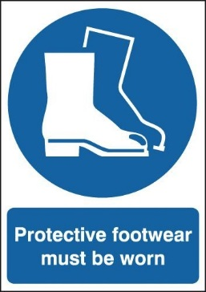
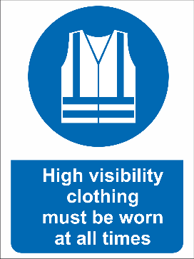
- Enclosed footwear.

General Site Rules

First aid
- You must report any incidents or injuries.
- Where first aid is required, site security can be contacted on 0408 334 555.
- Notify site security immediately if the emergency services have been contacted to attend the site.

Responsible Adult’s Acknowledgement

I acknowledge the conditions of entry to the Melbourne Market for a visiting child under 15 years of age and agree to comply, and ensure that the child visitor complies, with these conditions of entry. I confirm that the conditions of entry have been brought to the attention of the visiting child. I also acknowledge that each person who enters the Melbourne Market does so at their own risk and agree that the release and indemnity in Market Operating Rule 14 applies in relation to the child visitor.

Please note: Limit of two children per Access Card holder.

Applicant’s name:  ____________________________________  Signature:  ____________________________________ | Business nominee’s name:  ___________________________________  Signature:  ____________________________________

Your Checklist for bringing a child to the Market.

- Your work must be suitable to have a child with you at all times. E.g. if you travel on a forklift in the Market, it would not be suitable to bring a child to the Market as they must not ride on a forklift at any time and must remain in your care at all times.

- You must have submitted your registration in person to the MMA prior to arrival and been granted approval.

- Your child/children must be wearing their visitor pass at all times.

- You and your child/children must be wearing high visibility clothing.

- You and your child/children must be wearing enclosed footwear.

- You must enter via Gate 1.

