Request for Expressions of Interest

Commercial Opportunities, Ancillary Businesses, Melbourne Markets (Epping)

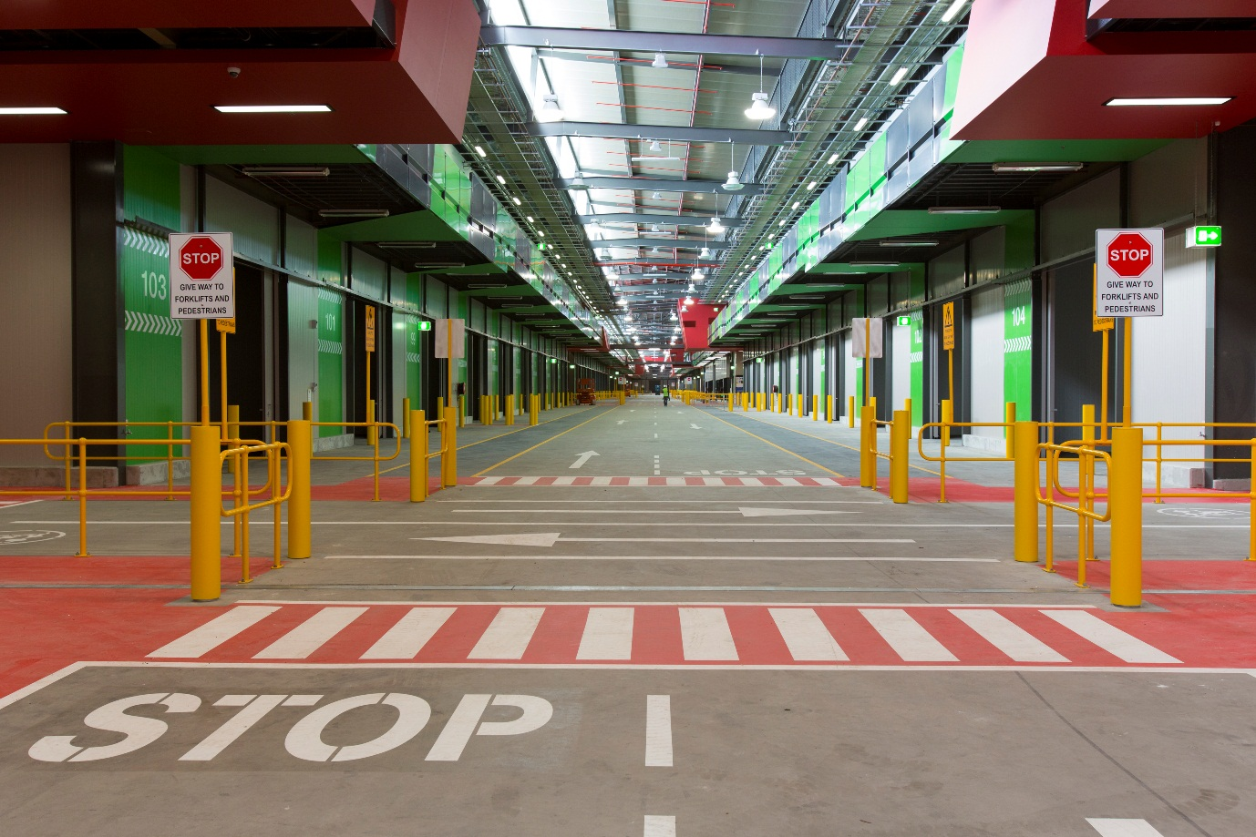

Ref: ECOMM100615
To be lodged by: 2:00pm, Friday 19 December 2014

Table of Contents
1 INTRODUCTION 3
1.1 Our business 3
1.2 The New Melbourne Market site 3
1.3 Site Objectives 3
1.4 Location 4
2 OVERVIEW OF REQUIREMENTS 5
2.1 EOI Submission Requirements 5
2.2 Form of Submission 5
3 IMPORTANT INFORMATION & EOI CONDITIONS 6
3.1 Details Schedule 6
3.2 Timeline 7
3.3 Site Inspection 7
3.4 Selection Process 8
3.5 EOI Conditions 8
Schedule 1 Acceptable Response Form 9

1 INTRODUCTION
In May 2014 The Melbourne Market Authority (MMA) sought to identify innovative commercial opportunities through an Expression of Interest (EOI) process.

The MMA now seeks to encourage businesses that did not participate or were not aware of the previous EOI to express interest by responding to this request. Although all types of businesses are encouraged to apply a specific focus of this EOI is to understand those entities that propose to provide services that would support a Tenant and/or Market User.

The size and scale of the New Melbourne Markets facility creates a variety of commercial opportunities to service the needs of the three thousand registered businesses and the greater market community operating and working at the market.

This EOI is the first stage of a two-stage process for selecting ancillary businesses to operate at the new Melbourne Markets site in Epping, Victoria. In the second stage, the MMA intends to invite proposals from shortlisted Registrants.
1.1 Our Business
The MMA is a statutory body delegated by the State of Victoria to manage the Melbourne Wholesale Fruit, Vegetable and Flower Market (the Melbourne Market). Its responsibilities include controlling, maintaining and promoting the use of the facilities of the Melbourne Market.
The MMA’s objectives are to:
- provide a commercially viable wholesale facility for the efficient distribution of fresh produce
- optimise returns on land and assets controlled and managed by MMA
- ensure a fair and competitive environment for the wholesale trading of produce.

1.2 The New Melbourne Market Site

In 2006, the State announced that the Melbourne Market would be relocated from its current site in Footscray Road to a new 64 hectares site in Epping, with the intention of redeveloping the Melbourne Market into a modern, innovative and efficient fresh produce trading and distribution precinct, expected to facilitate the growth of the Victorian food and fresh produce industries.
The New Melbourne Market reached construction completion in August 2013. The trading floor complex covers approximately 11 hectares and includes approximately 40,000m2 of trading floor area. The site will accommodate the Wholesale Fruit and Vegetable Market, the National Flower Centre and extensive distribution and warehouse facilities. There are around 150 varying sized stores in the Wholesale Fruit and Vegetable market. Although final numbers are not yet known for the new site, at the existing site there are more than 3,000 registered businesses operating and average daily attendance figures in excess of 7,000.
The Epping site has incorporated a suite of new thinking and applied lessons. The design of the site is underpinned by the idea to establish new environments that allow businesses to conduct their tasks easier, safer and the ability to manage costs more effectively. The benefits of the Epping site include:
- improvements to traffic management, access and parking
- increase in warehousing space allowing tenants who traditionally have located their warehousing offsite to now have their warehousing within the market complex
- upgrades to telecommunications and information technology including blanket coverage wireless coverage, local network capability, advanced closed circular television
- moving towards zero waste.

1.3 Site Objectives

It is expected that the New Melbourne Market will:

- provide market users with an innovative, safe and modern facility
- meet current and future needs for market users, including providing Market Warehousing in close proximity to the trading floor complex
- cater for modern logistics, cold chain management and security
- encourage innovation in transport, equipment in material handling, storage and information technology in the fresh food industry
- provide opportunities and benefits that come from being a part of an interactive fresh-food related business precinct in Epping
- provide market users with significant improvements in access and occupational health and safety.

Delivery of these objectives is anticipated to increase the frequency and duration of visits to the Market by tenants resulting in a greater need for ancillary businesses identified in Section 2.

1.4 Location

The decision to develop a world class central market in Epping not only supports the market’s needs in terms of space, it also provides transportation links to regional Victoria, growing regions as well as interstate.

In close proximity to the Hume Freeway, Craigieburn Bypass and the Western/Metropolitan Ring Road, the Cooper Street site allows for direct access to Melbourne’s main arterials. With the future introduction of the East West Link, the Epping location boasts many benefits for produce distribution through the road network and future development opportunities.

Some of these benefits include:

- proximity to direct arterial roadways and Melbourne’s international airport supports the future of the Victorian horticulture exports and the longevity of the markets
- increased space to allow for future development and expansion as well as opportunities for increased efficiencies for our tenants
- moving into one of the fasted growing municipalities in Australia with access to services, amenities and transport continuing to grow.

More information regarding the Melbourne Market Relocation Project is available at the following website: http://www.melbournemarkets.com.au/market-relocation/site-information/. A site plan of the New Market can be accessed via this link: http://www.melbournemarkets.com.au/wp-content/uploads/2012/01/SITE_PLAN.pdf

2 overview of requirements

The Melbourne Market Authority (MMA) invites Expressions of Interest (EOI) from ancillary businesses interested in operating at the New Melbourne Markets in Epping, Victoria.

Ancillary businesses include yet are not limited to;

- pharmacies
- dry cleaners
- post office and related services
- newsagencies
- medical centre
- employment services
- legal, insurance and other professional services
- freight forwarding and logistics

At this time the MMA is open to receiving responses from all types of ancillary businesses however a focus on entities that provide services that would support a Tenant and/or Market User are of special interest.
.

2.1 EOI Submission Requirements

Submissions at a minimum, must include:

- Names and addresses of any persons or entities having a financial interest in the submission
- The state in which the Registrant(s) currently conducts business and the nature of those operations
- Details of relevant experience over the last five years including Registrant(s) performance, and the names of at least three referees (where applicable)
- Skills, technical and professional expertise relevant to the submission
- A full description of the services to be offered, equipment to be used and methods to be adopted
- A description of how the proposal provides benefit to the New Melbourne Markets site
- Details of any relationship the Registrant has with employees and/or contractors of the MMA or related entities
- Such further information which covers the requirements of this expression of interest as deemed by the Registrant

2.2 Form of Submission

Interest can only be expressed by correct lodgement, and in the correct form as follows:

- you must ensure that your submission includes a signed copy of the Acceptable Response Form- Schedule 1 of this EOI document
- Registrants are requested not to alter the numbering or structure of this EOI Form
- all electronic documents must be virus checked by the Registrant before lodgement
- Registrants are asked to provide a response in accordance with the lodgement method and instructions noted in the Details Schedule

3 IMPORTANT INFORMATION & EOI CONDITIONS

3.1 Details Schedule

Description | Commercial Opportunities, Ancillary Businesses, Melbourne Markets (Epping)
Reference Number | ECOMM100615
EOI Contact Person | Matthew Elliott, Melbourne Market Relocation Project Team, Melbourne Market Authority
Email | matthew.elliott@melbournemarkets.com.au
Phone | (03) 9258 6105
EOI Issue Date | 7 December 2014
Closing Time | 2:00 pm Local Time in Melbourne  19 December 2014
Lodgement Details | Electronic submissions only:  Attention:  Matthew Elliott  Melbourne Market Authority  submissions@melbournemarkets.com.au  The Email; subject line should include: EOI Reference Number ECOMM100615 and Commercial Opportunities, Ancillary Businesses, Melbourne Markets (Epping) and [your business name]  Email attachments to comprise:  - One complete signed and scanned Expression of Interest including the Acceptable Response Form bound and marked; and  - One electronic copy of the complete Expression of Interest in “doc” or “docx” format not PDF
Question Protocols and Last Date for Questions | Questions or requests for clarification should be submitted in writing by email to the EOI Contact Person, no later than 2:00 pm, Tuesday 16 December 2014  MMA may elect not to answer questions or requests for clarification received after that time.  On a periodic basis, MMA will publish on the Melbourne Markets website answers to questions received. Questions may be edited including to remove the identity of the enquirer
Site Inspection (optional) | Option 1: Friday 12 December 2014 – 9:45am or  Option 2: Tuesday 16 December2014 – 11:15pm

3.2 Timeline
Expressions of Interest will be evaluated, and applicants will be shortlisted to participate in a Request for Proposal process in accordance with the following timeline:
Event | Indicative Date
Release of Request for EOI | 7 December 2014
Site Inspections (can only attend one of) | 12 & 16 December 2014
EOI close date | 19 December 2014
Review of EOI Submissions | December 2014/January 2015
Meetings with Registrants (if any) | As required
Request for Proposal Process | TBA

3.3 Site Inspections

Site inspections have been organised for the following days:
- Friday 12 December commencing at 9.45am
- Tuesday 16 December commencing at 11.15am

Registrants may attend only one of these inspections and only when they have registered in accordance with registration process detailed below.

Please note, additional landlord works are underway deeming the New Melbourne Markets site as a construction site and therefore access to the site must follow certain procedures.

Each site inspection will be structured as follows:
- meet outside the MMA Administration building at Epping. You will need to sign in when you arrive.
- site inspections will commence on-time and will take approximately 1 hour. Most of the relevant locations will be available for inspection. The MMA cannot guarantee that every location will be available for inspection due to the construction work.

How to register

Bookings are essential. In order to confirm a place for one of the allocated times listed above, attendees must email submissions@melbournemarkets.com.au and include their business name, attendee names and a contact telephone number. You will need to register your attendance at least two business days before the site inspection date. Please note that space is limited to a maximum of 2 people per business so it is advised that you book in advance to secure a place on your preferred date.

Getting there

Attendees will be required to make their own travel arrangements to Epping. The Market is located at 315 Cooper Street Epping. You can enter the Market via the Cooper Street and Gateway Boulevard intersection where you will proceed directly to the Administration Car Park (approx. 100m in front of the Administration Building). Please note this is before you get to the Gate 1 boom gates. Should you be travelling in a heavy vehicle, please notify the MMA of this at the time of booking.
Clothing

All visitors to the Epping site are required to wear closed toe shoes and a hi-visibility safety vest (vest will be supplied on-site).

3.4 Selection Process

Evaluation and selection of a preferred Registrant(s), if any, will be based upon demonstration of:

- the creativity of the proposal itself, including the level of benefit the service offered by the Registrant provides the Epping site
- the consistency of the proposal with the site objectives
- the managerial and technical capacity of Registrant to provide services
- the Registrants previous experience and previous business success
- the adequacy of the Registrant’s human and physical resources
- the quality of other submissions presented to support the Registrant’s proposal
All submissions will be opened and registered together. The MMA is not obliged to consider applications received after the closing time.

3.5 EOI Conditions

The Registrant agrees, by lodging an EOI:

- that it is bound by these Conditions
- to lodge its EOI as requested by the Closing Time
- to submit all documents as required by the MMA (the EOI Documents) in the format set out in Section 2 and Schedule 1
- that EOI Documents become the property of the MMA upon lodgement
- to keep EOI Documents succinct and free from elaborate artwork, bindings or any other forms of unnecessary presentation
- that it warrants that all information in the EOI Documents is accurate and complete
- that it will keep confidential any confidential information provided by the MMA in connection with the Request for EOI
- that it will make any inquiries relating to the EOI process only through the Contact Person
- not to reproduce the MMA’s documents (or any part of them) except where necessary for preparation and submission of its EOI
- that pursuant to the Information Privacy Act 2000 (Vic), it will be bound by the Information Privacy Principles and any applicable Code of Practice with respect to any act done or practice engaged in by the Registrant in connection with this EOI process in the same way and to the same extent as the MMA would have been bound in respect of that act or practice had it been directly done or engaged in by the MMA.
- to licence the MMA to use and reproduce the whole or any portion of the EOI Documents for EOI evaluation and audit.

The MMA,

before receipt of the EOIs, may:
- change any details relating to the Request for EOI process or the Outline of Requirement
- extend the Closing Time

following receipt of the EOIs:
- may invite tenders from selected Registrants and others
- may undertake investigations and discussions with any Registrant or other party in relation to the requirements
- may negotiate with one or more Registrants
- will evaluate EOIs against the evaluation criteria set out in the Details Schedule.
- does not warrant the accuracy or completeness of the information it supplies and the MMA is not liable for any deficiency therein
- Is not bound to proceed further with any EOI or the EOI process or the subsequent tender stage.

schedule 1- ACCEPTABLE RESPONSE FORM

Registrant Details
Registrant Name
Trading Name
Legal entity type
Address
ABN
Website

Registrant Contact Details
Contact Person
Name
Position
Email
Phone
Mobile

I/we acknowledge that the information provided will form the basis for evaluation of my/our Expression of Interest submission and accordingly I/we declare that all information is to the best of my/our ability, true and accurate
I/we warrant that I/we made my/our own investigations into relevant matters prior to submitting my/our interest and that I/we have formed my/our own views on the information that I/we have obtained.
I/we warrant that we have not relied on oral or written representations by the Melbourne Market Authority when preparing my/our submission or when assessing whether to submit interest
I/we make the above submission knowing that it is subject to the approval of Melbourne Market Authority and any other person/entity who has an interest in the site

Registrant Authorisation & Acknowledgement
Signature of Registrant’s Authorised Signatory | Date

